CURRENT EVENTS CLUB
Vision : To enhance students’ general knowledge
Mission :
To create a realization that knowledge is power
To make our students socially relevant
Staff –in –Charge (2019-2020)
1.Dr.L.R.Charlet Sharmili
Assistant Professor in History
2.Dr.J.Preethi
Assistant Professor in English
3.Dr.S.Jhonsi Rani
Assistant Professor in Tamil
4.Mrs.G. Saratha
Assistant Professor in English
5.Miss.J.Jhonsi Prema
Assistant Professor in Computer Science
Activiies :
Year | Date | Activities
2014-2015 | 24.07.2014  09.08.2014  23.10.2014  17.02.2015  09.03.2015  08.04.2015 | Quiz, Essay ,Elocution and Pencil Sketch  competitions  Written Quiz  Written Quiz  Pencil Sketch and Verse Writing competition  Theme: “Save our Mother Earth”  Essay competition  Theme: “Real the world –make it a better place for Human Race”.  Inter-Collegiate Competition  “Coruscatus 2015”
2015-2016 | 03.08.2015  25.08.2015  12.08.2015  03.08.2015  29.10.2015  27.01.2016 | Quiz, Essay ,Elocution and Pencil Sketch  competitions  Delivered a Talk on “Dr.A.P.J AbdulKalam “given by Siva Punitha of III History.  Written Quiz  Delivered a talk on “Solid Waste Management” given by M.Gayathri III Chemistry.  Written Quiz  Written Quiz
2016-2017 | 21.07.2016  02.08.2016  26.09.2016  07.02.2017 | Quiz, Essay ,Elocution and Pencil Sketch  competitions  Delivered a Talk on “Women‘s Rights” given by Nandhini of III B.A History.  Oral Quiz on “Olympics – 2016”  Written Quiz
2017-2018 | 23.08.2017  28.09.2017  12.12.2017  16.01.2017  12.02.2018 | Delivered a Talk on “Role of MNCS increasing the plastic wastes in India” given by Niraimathi of III B.A .Chemistry  Written Quiz  Written Quiz  Delivered a Talk on “Burning Problem of Today” given by Jeyashree of III Maths.  Written quiz
2018-2019 | 02.08.2018  04.02.2019  11.02.2019  01.03.2019  01.03.2019 | Delivered a Talk on How to make Prepare and Qualify in NET and SET Examinations given by Shareena Jasmin, Assistant Professor in History.  Disadvantages of using Plastics for man Kind given by S.Jahira Kashifa of III Physics  Delivered a Talk on Currency change in India given by R.Anjugam of III B.A.History  Delivered a Talk Current Events Questions for Competitive Examinations given Mr.C.Murugeshwaran,Co.ordinator,Kama Academy and SUITS Bharathidasan University,Tirchy and Mr.G.Senthil Kumar ,Co-Ordinator,Thinnai Payirchi Pattarai,Theni  Delivered a Talk Climate Change and Energy Innovations given by Dr.Mrs.M.Kalanithi,Associat professor of Chemistry ,Jayaraj Annapackiam College for women, Periyakulam.  Written Quiz

2019-2020 Activities:
The activities of the Current Events Club for the year 2019-2020 commenced with the Inauguration on 12.07.2019.K.Anitha (III Maths),M.Nagabala II B.A.History (E.M) were elected as Secretary and joint secretary respectively.
A written quiz -1 on General knowledge was conducted on 28-8-2019. The winners are Ms.P.Jeevitha,II B.Sc Physics (R) I Place, Ms.G.Nivetha Harini, II B.Sc Physics (R) & Ms. R.Megavarshini,III B.Sc Zoology(R) II Place respectively.76 students participated in it.
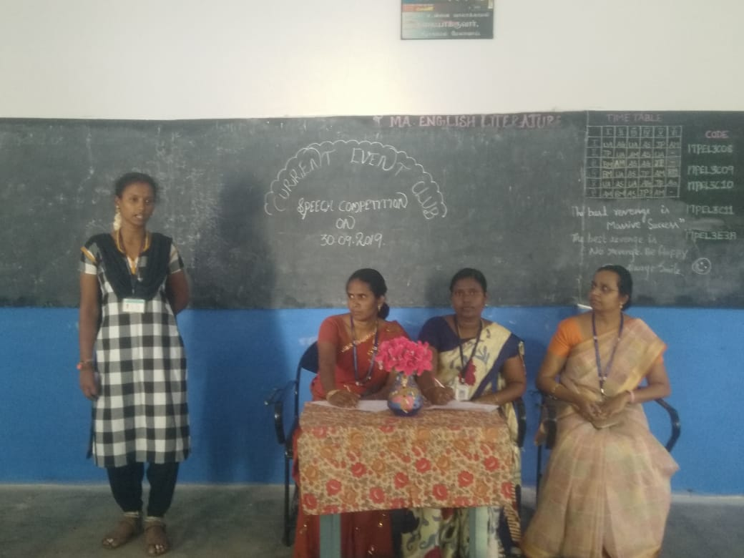
Current Events Club Conducted a Speech Competition on 30-09-2019
Current Events Club conducted a Speech Competition on 30.9.2019 at 3p.m in Room No: 38. 1) Fit India Movement.2) India’s Sagging Condition of Economic Growth. 3) Interlinking of Bank. 4) Merits and Demerits of conducting Board Examination for 5th and 8th standard school students. 5) Clearing NET/SET as eligibility criteria for becoming a Professor .were the given topics and 15 students participated in it. The prize winners are A.Fatimitha Fatima,Physics(R) I Prize, Ramya III Eng(R ) II Prize, Durga II History (EM) II Prize, Mathavilatha I Physics(R) respectively.

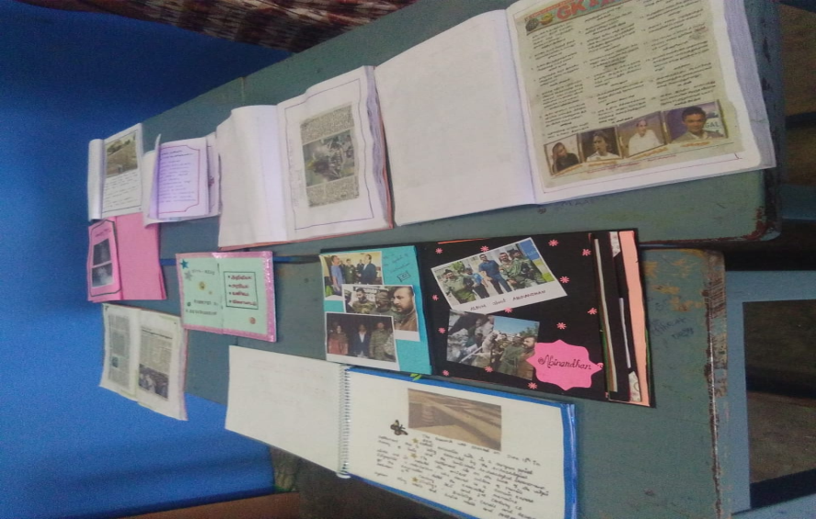
Current Events Club Conducted an Album making competition on 28-10-2019
Current Events Club conducted an Album making competition on 28.10.2019 at 4.30 P.M. 15 students were participated in it. The prize winners are G.Buvaneshwari,I B.Sc Phy(S.F)I prize,M.Mathavilatha,I B.Sc Phy(R)II
Current Events Club conducted an Essay writing Competition on 21.01.2020 at 3.00 p.m in Room No:38. 1)The Citizenship (Amendment) Act, 2019 2) Khelo India Scheme 3)Chandrayaan – 2 were the given topics and 35 students participated in it. The prize winners are M.Nagabala (HEM) I Prize, M.Pandipriya (HEM) II Prize respectively.

