FACULTY PROFILE

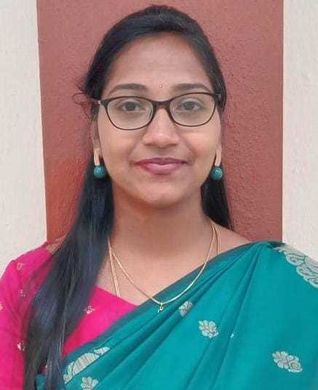
Name : L.P. PRIYANKA MA., M.Phil., NET
Designation : Assistant Professor
Department : English
Date of Birth : 12. 04.1994
Date of Appointment : 22.03.2021

ACADEMIC PROFILE:
S.No. | Degree | Name of the Institution | Board/ University | Year of Passing
1 | B.A. English | Bishop Heber College (Autonomous), Trichy | Bharadhidasan University, Trichy | 2014
2 | M.A. English | Holy Cross College (Autonomous), Nagercoil | Manonmaniam Sundaranar University, Trinelveli | 2016
3 | M.Phil. English | St. Mary’s College (Autonomous), Thoothukudi | Manonmaniam Sundaranar University, Trinelveli | 2017
4 | NET | NTA | University Grants Commission | 2022

Persuing 400 Hour International Post Graduate Diploma in TEFL/TESOL Program at Asian College of Teachers in online mode.

Total Years of Experience : 5 years 7 months
Area of Specialization/ Interest : African Literature and Cultural Studies

RESOURCE PERSON:
Delivered a Guest Lecture on the topic “Representation of Women with Special reference to African Literature” in the Faculty and Student Exchange Programme held at Teresian College, Mysore.
ACADEMIC AFFILIATION:
- Member of HOPE Club
- Member of Physical Education
- Member of The English Dramatics
- Member of Women’s Cell
- Member of Consumer Club

PAPERS PRESENTED:
- Presented a paper on “ The Unresolved Ideology of Intersectionality in Chimamanda Ngozi Adichie’s Americanah” in an International Conference held at KG College of Arts &Science
- Presented a paper on “Tragic Flaw: A Study of Tennessee Williams’ A Streetcar Named Desire and Lorraine Hansberry’s A Raisin in the Sun” in National Level Seminar at St. Mary’s College (Autonomous), Tuticorin.
- Presented a paper on “Portrait of Women in Shakespeare’s Othello, Julius Caesar and The Winter’s Tale” at VOC College Tuticorin.

SEMINAR/ CONFERENCE/ WORKSHOP ATTENDED:
- Attended a FDP on “Insights to Research Metrics, Ranking Parameters and Institutional Patents” under National Intellectual Property Awareness Mission, organized by Research Committee and IQAC, Jayaraj Annapackiam College for Women (Autonomous), Periyakulam.
- Participated in the Web Lecture “Reading, Writing and Being Creative”, an interaction with poet Dr. Syam Sudhakar organised by PG Department of English, Jayaraj Annapackiam College for Women (Autonomous), Periyakulam.
- Participated in the National Webinar on “Literature, Culture and Media: A Semiotic Intersection” organised by research centre of English, Fatima College (Autonomous), Madurai.
- Attended a one day Workshop on “Outcome Based Education” organized by Jayaraj Annapackiam College for Women.
- Participated in the Two day virtual International Conference on “Maritime Footprints: Crafting the Cultural Landscape of Littoral Zone” organized by St. Mary’s College (Autonomous), Thoothukudi.
- Participated in the online Webinar on “Tribal Literature” organized by the Department of English. Arputha College of Arts and Science for Women, Pudukkottai.
- Participated in an International Webinar on “Classroom Management” conducted by Asian college of Teachers.
- Attended the online Faculty Development Programme on “Programming the Mind with creative Visualization” organized by Mary Matha Collge of Arts and Science, Periyakulam.
- Participated in Four Days Webinar on “An Effective Research Paper Writing Skills” conducted by Bhagwan Mahavir University, Surat, Gujarat.
- Participated in the Intercollegiate Seminar on African Literature in English held at Muslim Arts College, Thiruvithancode.
- Participated in An Interactive Regional Workshop on English for My Career held at Holy Cross College, Nagercoil.

CONTACT DETAILS:
Permanent Address : 1-3-60G, JRR Nagar,
Vaigai Dam Road,
Thenkarai,
Periyakulam,
Theni District- 625601
Mobile Number : 8668021994
Email : priyankaeng@annejac.ac.in

